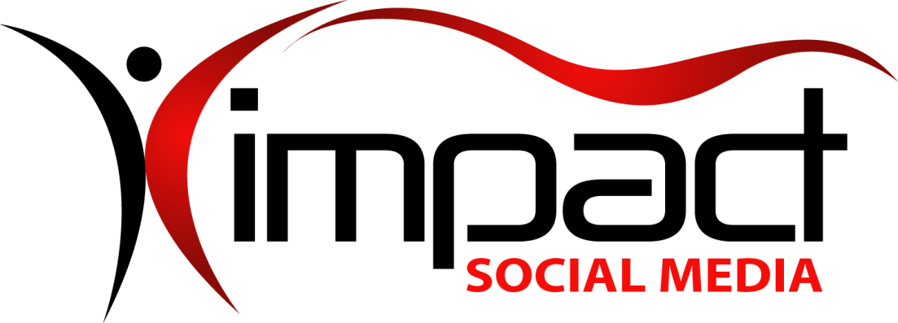
Got Impact? Get Impact! How? With Impact Social Media!
Follow Us!

Visit us on the web: http://impactsocialmedia.net

Impact Social Media All About Logos
Link to Impact Social Logos: http://impactsocialmedia.net/advertising-graphics/all-about-logos/
Description: Simply put, a logo is the embodiment and recognizable face of your company or organization. Your logo will be used extensively in everything you do from your business cards to your website and social media pages. In other words, your logo will be continuously in the public view and is a critically essential branding element. This is why we must place so much emphasis on the importance of a well thought out and professional logo design. Your logo needs to be right from the very beginning as this is a long-term commitment and you do not want to be changing it mid-stream.

Impact Social Media Logos Table Of Contents
Contents
I. Qualities of a logo 3
1. Logo qualities 3
II. Logo Types 3
1. Font based logos 3
2. Icon based logos 4
3. Tag line logos 5
III. Color Palette 5
1. Selecting from the color palette 5
IV. Font Styles 6
1. Selecting the right font 6
2. Selecting the look and feel 7
V. Logo Design Methodology 7
1. Step one – Information gathering 7
2. Step two – Research 8
3. Step three – Hand drawn sketches 8
4. Step four – Computer drafts 8
5. Step five – Drafts collaboration 8
6. Step six – Finalized design 8

Qualities of a logo

Logo qualities
So the next question is, “what are the qualities of a proper logo?”
- It defines and projects the company image
- It promotes credibility and publicity
- It is easy to remember
- It is recognizable
- It is simple and focused
- It is distinctive and unique
- It is easy to read regardless of how big or small it is
- It is based upon a timeless design
- It is effective in all types of promotional media
- It is adaptable to different background colors and textures
Now that we have a basic understanding of the qualities of a good logo, we should briefly discuss the different types of logos. No one specific type of logo is necessarily always the best choice. Each of the different types should be carefully considered as to which one is the best fit. The process of logo type selection is on a case by case basis as no two businesses or organizations are exactly alike.

Logo Types

Font based logos
Font only – Just a font with no symbolic intervention
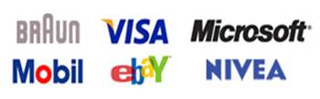

Font plus meaning – A tweaked font with symbolic intervention
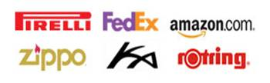
Font in a shape – Font is inside of some type of shape(s)
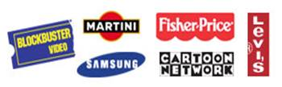
Handmade – Calligraphy, handwriting or script design
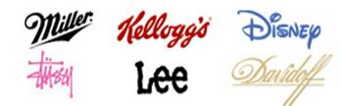
Initial – Initials are used in place of the full name
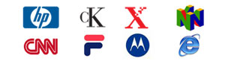

Icon based logos
Abstract graphic – A graphic symbol representation only
Detailed illustration – Illustration or pictorial representation
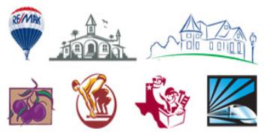
Geometric symbol – Geometric symbol depicting an element

Illustrated symbol – Illustration depicting a clear symbol
Mascot – A character representation
Seals and crests – Detailed seal or crest with just text or may include graphics
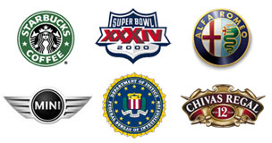
Silhouette – Detailed, illustrated silhouette

Tag line logos

Three to seven word phrase – Incorporated into the logo design
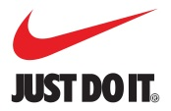

Color Palette

Selecting from the color palette
After considering which type of logo to use, it is time to move onto color palette selection. Depending on the type of logo used, one color may be sufficient. For other logo types, two or more colors will be needed.
When choosing colors, it can be beneficial to have a general understanding of the different meanings that colors can convey. Bear in mind that not all cultures or people will interpret colors the same. For the purpose of this discussion we will limit our focus to western perceptions.
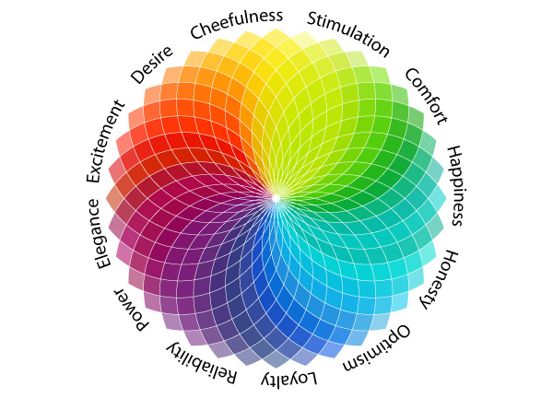
As shown in the illustration above colors can have a psychological impact on the viewer. Bearing this in mind, color palette selection can be utilized to enhance the effectiveness of the logo design.
For instance, red can be used to convey intensity and this can be witnessed by examining the Red Bull logo. If you look at a simple Microsoft font only logo you will see the use of black which sends out a signal of authority or power. Pick your colors wisely for more impact.
Black and Red – Red = intensity | Black = authority and power
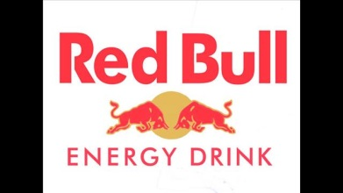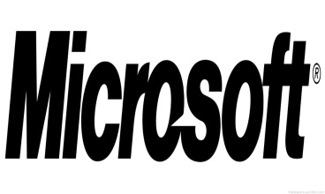

Font Styles

Selecting the right font
Once the color palette decisions are made it is time to pick out a font style group. Font styles impact the overall design by conveying a certain type of feel. Just as with color selection, you can maximize the message of your logo design by utilizing the right font style.
In the examples listed below the message conveyed by the font type is illustrated to give a more clear understanding of the concept. Always pick the font style that will enhance the logo’s message.
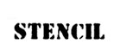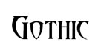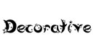
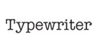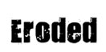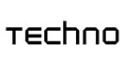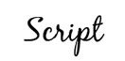

Selecting the look and feel
Last but not least, is determining the look and feel that will be most beneficial for the logo design. The look and feel of the logo gives it a certain character.
When the look and feel is a good fit, the logo sends a loud and clear message while simultaneously enhancing the long-term branding effectiveness. Examine the look and feel of the logos shown below to get a more in depth grasp of the importance of making the right choice.
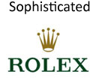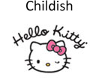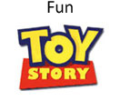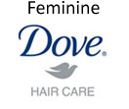

Logo Design Methodology

Step one – Information gathering
Now that we have covered all of the various choices affecting the logo design, it is time to discuss the actual logo design methodology. At Impact Social Media our first step is to gather all of the information that has just been discussed. This gives us a very good generalization of your logo needs and creates a starting point for the design process.

Step two – Research
The second step is to do some research on your company. This includes getting a feel for your branding, image, industry, services and products. At this time we will also do some industry specific research and examine the demographics of your target market. The last phase of this second step is additional research into your competitor’s logos and branding techniques.

Step three – Hand drawn sketches
The third step is where the real fun begins as the actual design work gets underway. To the wonder of many, our initial design work does not begin on a computer!
We typically begin the initial logo design work with paper sketches, hand drawings and a bit of brain storming. There is something magical about putting ideas to paper and then giving some time to reflect and ponder all of the available design options.

Step four – Computer drafts
Once a desirable sketch has been created we begin the fourth step. In this step the drafting design work moves to the computer where we do the development in vector graphics using Adobe Illustrator.
Vector graphics are mandatory as this allows for scalability of the finished product so that it can be used on a business card or a billboard without sacrificing appearance quality. The computer drafting design phase is complete once we have produced at least three different logo designs.

Step five – Drafts collaboration
Step number five begins with providing you with several potential logo designs. During this step we give you time to analyze and give us feedback. We will collaborate closely with you during this step to ensure that we fully understand your analysis and recommendations on the provided drafts.

Step six – Finalized design
The sixth and final step involves incorporating your feedback from step five into a finalized logo design. The finalized logo design may be subject to minor revisions at your request. Once any finalized revisions are completed we will provide you with copies of your completed logo in all of the most common formats such as .ai, .png, .jpg, .gif, and .pdf.

Impact Social Media specializes in the development and creation of effective and unique logos that will enhance your branding and professional image. We offer quick turn-around times coupled with affordable pricing. We are uniquely focused on the needs of startup companies and small to medium sized businesses, charities and organizations.
We are able to offer you standard and animated logos in vector based designs. We are located in Lee’s Summit, Mo. which is in the greater Kansas City area and we serve clients around the globe. If you have questions or need logo assistance contact us today.

You can learn all about web design at the following URL:
http://impactsocialmedia.net/startup-company/all-about-websites-a-beginners-complete-guide/

You can learn all about graphics design at the following URL:
http://impactsocialmedia.net/advertising-graphics/all-about-graphics-design-elements-and-methodology/

You can learn all about domain names at the following URL:
http://impactsocialmedia.net/domain-names/what-is-a-domain-name/

If you have questions or need assistance you can email us at:
sales@impactsocialmedia.net

You can also call us at 816-743-0525

Got Impact? Get Impact! How? With Impact Social Media!

