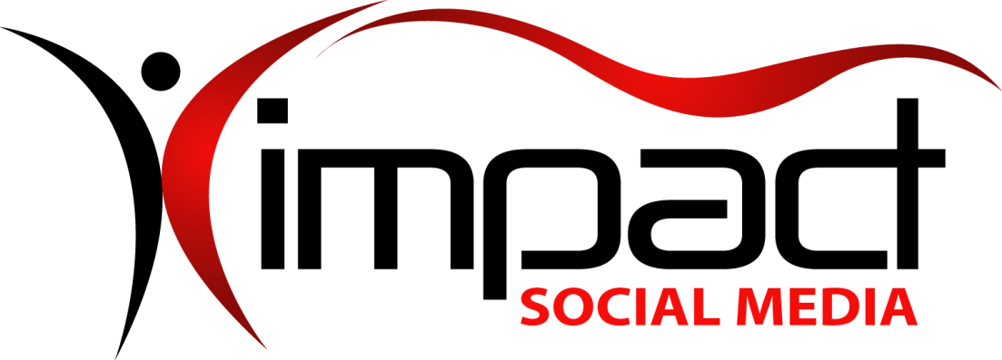
Got Impact? Get Impact! How? With Impact Social Media!
Follow Us!

Visit us on the web: http://impactsocialmedia.net/

Impact Social Media

Shipping Policy

Impact Social Media – Shipping Policy URL: http://impactsocialmedia.net/shipping-policy/

Impact Social Media Shipping Policy
When will my order be shipped?
You can trust that your order will be quickly processed and safely delivered. Once we receive notification of your shipping request and choices we typically have your package delivered to the shipper within 24-48 hours. The only exception to this would be if we receive your order on a Friday, Saturday, Sunday or Holiday in which case we will have your package delivered to the shipper within 24-48 hours of the next business day that we are open.
Where can we ship your order?
We can ship products anywhere in the United States or internationally using the shipping method of your choice. When you place an order we will estimate delivery dates based upon the information which the shipper provides to us.
Which carriers can I pick from?
- United States Postal Service™ – Visit Site
- UPS™ – Visit Site
- FedEx™ – Visit Site
- DHS™ – Visit Site
How much will the shipping cost?
We do not markup the shipping fees or package insurance and we do not charge any fees for handling or packaging. Your shipping cost will be dependent upon the size and weight of your package, the carrier you choose, your location, chosen speed of delivery, and required insurance amount. You will be notified of shipping costs prior to your package being sent out so that you may approve the fee or make alternate choices as needed.
How will the item be packaged?
Everything we ship out is professionally and securely packed to prevent in transit damage. We also give you choices as to the format in which your items are sent to you. You can choose whether your item is in printed form, digital form or both. If you choose a digital form you also have a choice as to what storage medium is used for the digital media.
Items which you may choose to have printed:
- Graphic artworks (Logos, Ad artwork, Brochures, Banner ads, Business cards, etc.
- Reports (SEO analysis, competitor analysis, keywords analysis, traffic statistics, etc.
Items which you may choose to have sent on a digital storage medium:
- Graphic artworks (Logos, Ad artwork, Brochures, Banner ads, Business cards, etc.
- Reports (SEO analysis, competitor analysis, keywords analysis, traffic statistics, etc.
- Backup copies (Website, Database, Applications, Software, Scripts, etc.
Types of digital storage mediums you can choose from:
- CD Rom
- DVD Rom
- USB Stick
What about returns?
For any information on returns please refer to our Return Policy.
If you have any questions about or need to make use of our shipping policy, please choose one of the following options which is most convenient for you:
- Call our customer support department at 816-743-0525
- Email us at sales@impactsocialmedia.net
- Submit a support ticket at our customer portal
- Send mail to or visit our office at 4913 SW Gull Point Dr., Lee’s Summit, MO. 64082

