Got Impact? Get Impact! How? With Impact Social Media!
Follow Us!

Visit us on the web: http://impactsocialmedia.net/

The Current Pulse of Social Media - 2014
Statistics, Trends, Predictions
The Current Pulse of Social Media – 2014 URL: http://impactsocialmedia.net/social-media-marketing/the-current-pulse-of-social-media-2014-statistics-trends-predictions/
Social media is evolving right before our eyes. The industry is quick paced and platforms rise and fall. Sometimes quickly and sometimes slowly. 2013 was an exciting year for social media but that year is now history as we move into the first quarter of 2014.
2014 promises to be another exciting year for social media and we do our best to keep our fingers on the pulse at all times. We have been monitoring a wide variety of platforms in 2013 and have given the last 6-12 months a good hard look. This gives us a decent grasp of where things stand as we begin 2014 and it also gives us a bit of insight to make some predictions as to what we might expect to see as we move forward.
We have written this article based on the data that we have observed. Our position is unbiased as we have no vested interest in whether a particular platform fails or excels. Our goal is to share with you our humble opinions and it may not be what you want to hear but it is not designed for popular opinions but instead to give you some solid ground on which to base your social media development strategies as we move into 2014.
We have examined 42 of the very topmost social platforms for this writing. After careful consideration we decided to mention 23 of those platforms and we have divided those 23 into 4 different categories as follows:
- The Superstars
- The Most Under Rated
- The Ones To Watch -HOT-
- The Sinking Ships
The Superstars
FaceBook
Facebook is the undisputed King Kong of any social media platform on planet earth. We anticipate that it will maintain this position throughout 2014 as there is no potential challenger to displace it.
Twitter
Twitter is the next rockstar of social media and is one of the most successful platforms on earth. We anticipate that it will remain solid through 2014 as it gains more global penetration. With the release of advertising opportunities it has additional leverage to gain from more commercial use.
LinkedIn
LinkedIn is one of the very top players in social media today and we see no reason for it to decline in 2014. We anticipate LinkedIn to begin stealing market share from Google Adwords and other marketing choices. This is because of their unique and incredible offering of being able to precisely pinpoint exactly who sees your advertisement.
Pinterest
Pinterest will likely continue to gain even more ground against the competing giants. Pinterest is very easy to use and benefits from its very simplistic user interface. Now that Pinterest has released advertising opportunities we think it will gain from more commercial usage in 2014.

Tumblr
Tumblr has been strong for years and now sports something like 20+ million user blogs! Because Tumblr allows for theme customization and the ability to create, own and run a blog at no cost we anticipate them to be stable or showing steady growth throughout 2014.
WordPress
WordPress has become the dominant engine for blogging style websites. They are also similar to Tumblr in that they allow users to create, own and run a full fledge blog at no cost. Because they are so well known and highly thought of we predict that they will show stable and steady growth moving through 2014.
The Most Underrated
CafeMom
CafeMom is the only social media site that is strictly for moms. They offer a very specialized platform that is incredibly valuable. Although they have been around for a long time and are used by some of the biggest names in retail for product testing, they simply do not get the recognition they truly deserve.
Live Journal
Live Journal is surely the most sophisticated and advanced blog platform in the world. For example, you can voice call a phone number they provide and speak your blog post into your phone and it will then be automatically converted and posted onto your blog as text! Oddly enough and with such amazingly advanced capabilities, Live Journal is not at the top of the blog pile and so we think it is very underrated indeed.
StumbleUpon
StumbleUpon is a very entertaining platform that offers a wealth of interesting websites. StumbleUpon is a top choice for bringing legitimate web traffic to a site and will simply produce amazing web page hits without spending a dime. The substantial benefits of this platform seem to go unnoticed for some strange reason.
Plurk
Plurk is hard to explain as to why they are not a dominant force. They allow for total customization of the appearance of the user interface. They have an excellent overall design with many cool features such as their horizontally scrolling time line. If you compare Plurk side by side to Twitter you might quickly conclude that it is substantially better and yet it just does not seem to get the market share of the very top platforms.

SecondLife
SecondLife is possibly the most underrated social media platform of all. They are simply so far ahead of their time that they are hindered by being so advanced. SecondLife offers everything you would find in any other social platform but with much more advanced elements.
Everything exists in a 3 dimensional world with actual physics built into the programming. The avatars can live chat with audio and video while interacting in a fully realistic 3d environment. There is also a micro economy whereby you can create, market and sell items in such a way as to have a profitable business there. For whatever reason, this platform is not well known in social circles.
MySpace
Myspace should be one of the very top performing platforms out there but it simply is not performing well at all. If they could just get people in there to see how amazing the place is these days I think they would take off like a rocket. The problem with Myspace is the vast majority of people have it set in their minds that the Myspace of today is the same old Myspace of years gone by and yet nothing could be farther from the truth.
The Ones to Watch
FourSquare
FourSquare is showing some very strong and sustained growth. This platform has excellent potential to carry this trend through 2014.
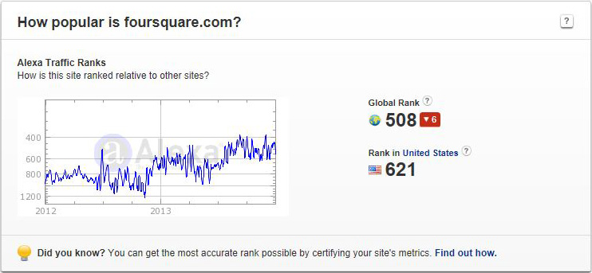
Foursquare is showing strong-sustained upward growth
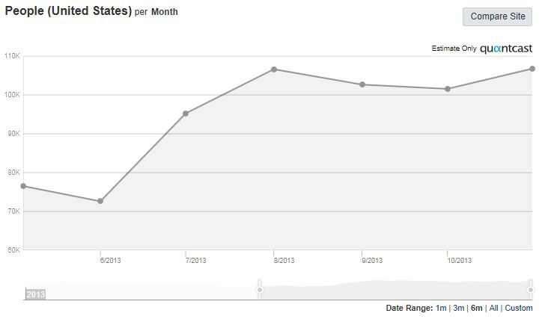
You should be using Foursquare for local marketing
Instagram
Instagram has had our attention for a while now and we anticipate it to be a very strong performer in 2014.
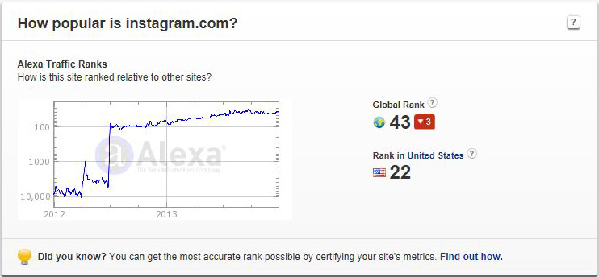
No slow-down in sight for Instagram
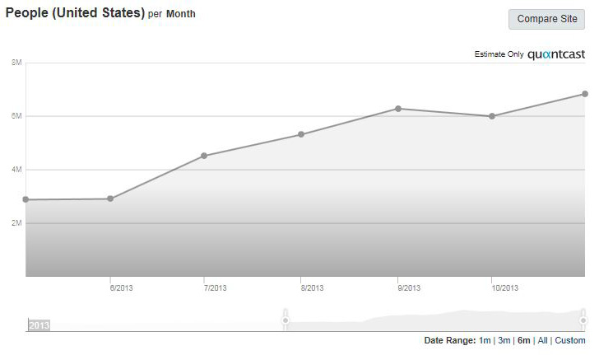
If Instagram doesn’t impress you the problem is you not Instagram

Reddit
Reddit is a sort of sleeping giant in that many people will not realize how amazing it is until one day soon it just seems to suddenly appear at the top of the social media pile.
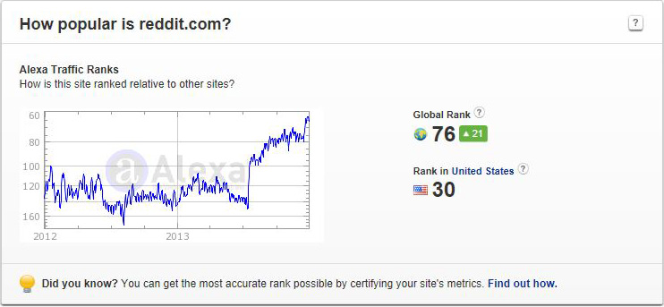
Reddit is the sleeping giant of social media so be on the lookout
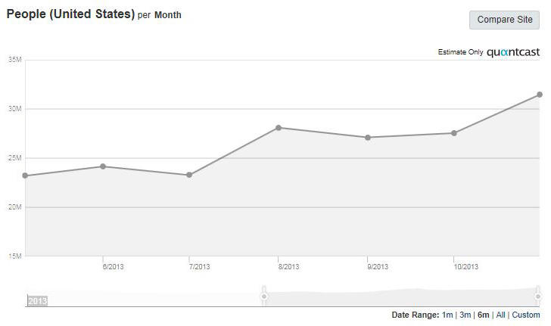
We predict Reddit to show good growth in 2014

SnapChat
SnapChat has been exhibiting an explosive growth pattern and we are convinced it has good potential to grow very rapidly through 2014. It is a big hit that has propelled rapidly as a result of the very unique twist and fun factor that it adds to text messaging.
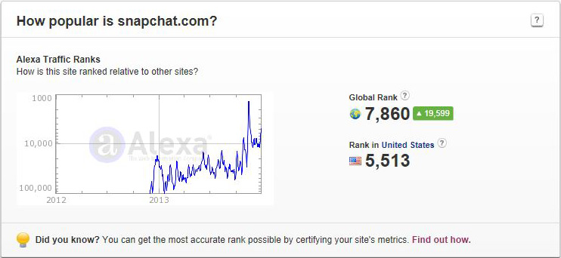
Although a late comer SnapChat is doing excellent
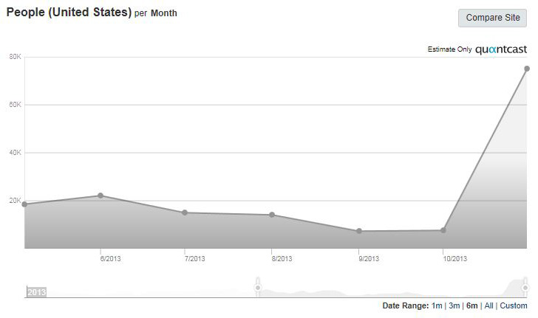
Maybe a slow start at first but look at SnapChat taking off now

SoundCloud
We have watched SoundCloud overtake other competitors rather rapidly. We predict that it will continue to grow strongly through 2014. Maybe even a potential threat to YouTube!
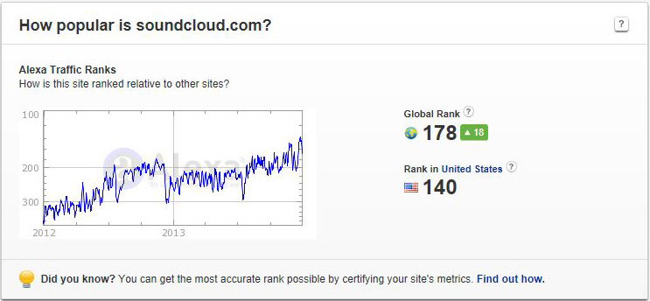
SoundCloud is looking very good for 2014
VK
Although VK has not shown an explosive growth pattern in the last 12 months it has been stable and steadily climbing. We think that it needs to be at the top of the watch list because it is a dominant force in Europe and is truly capable of reaching the very top of the social media pile.
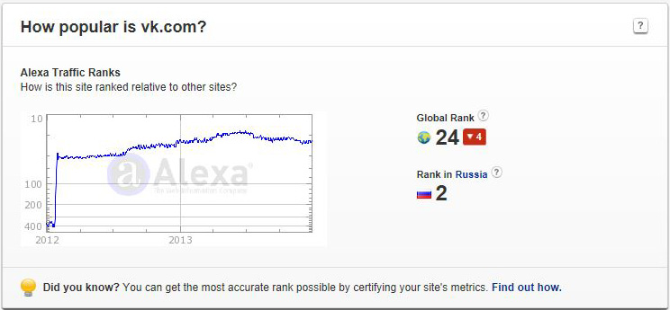
It would not be wise to ignore or underestimate this giant
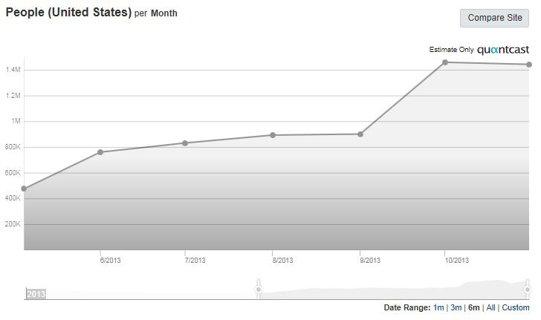
VK is not well known in the USA but that doesn’t seem to be hurting them much
Wanelo
If Wanelo is not on your radar you need to put it there. This platform has been amazing us for some time now and we are convinced it will show very strong growth through 2014.
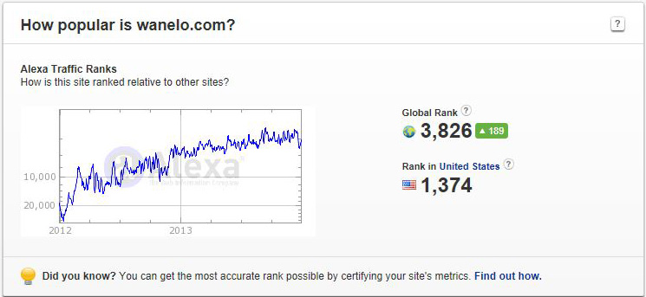
We have had strong expectations for Wanelo and they have not disappointed us
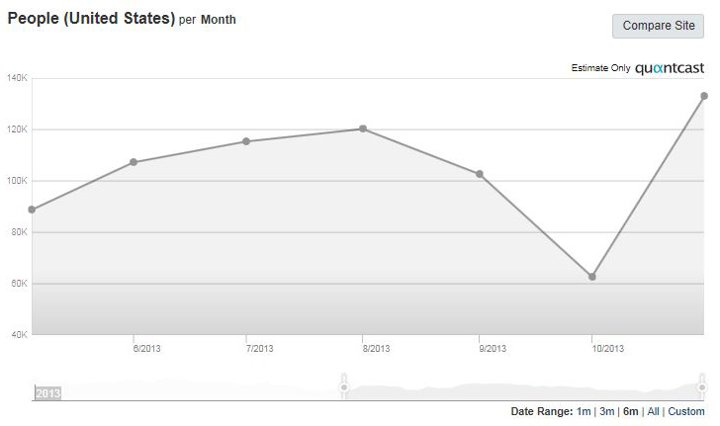
If you sell stuff online you should already be building at Wanelo

Weheartit
If Weheartit is not on your radar it should be. This platform is poised to become a potential competitor to Pinterest and has impressed us with strong and sustained growth for some time now. We are already developing our presence there as we anticipate a bright future for them.
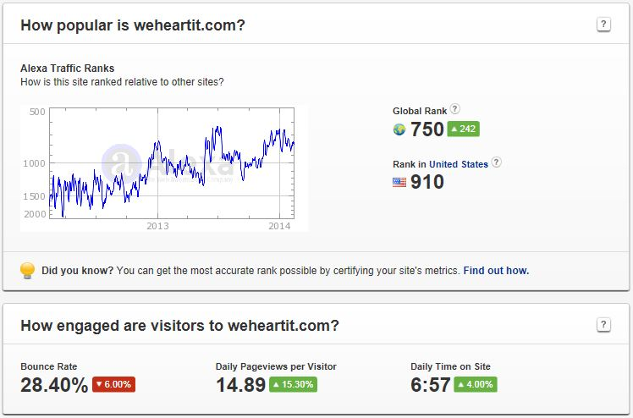
It is getting way harder to ignore this rising Pinterest competitor
Google+
For some time we were of the opinion that Google+ had lots of great potential but suffered from a form of identity crisis. It’s not Facebook because all of your friends and family are not there. It’s not Twitter because it lacks that fast-paced stream of interactions. It’s not LinkedIn as you will note a ton of well-known businesses have no presence there.
We feel that the identity crisis of Google+ has peaked and it is beginning to settle into its niche. The bright and shining stars of Google+ have turned out to be the communities and the hangouts. Google+ is shaping up to be more resembling an alternative to LinkedIn than FaceBook. We think Google+ will turn out to be a noteworthy social platform best suited for B2B and B2-Consumer activities. Couple that with the fact that Google+ does well on the Google search engine and we predict this platform to have sustained and strong growth through 2014.
The Sinking Ships
Delicious
Although we are huge fans of Delicious and use it for entertainment and exposure of content we regret to say it is in a treacherous decline. From 2012 until mid 2013 we watched with dismay as Delicious fell and fell and fell. We were happy to see them gain a bounce back from mid 2013 until the fall of 2013 but unfortunately that bounce was short lived. Currently, Delicious is showing a slow downward trend and we fear that if something does not give they may not experience any big recovery during 2014.
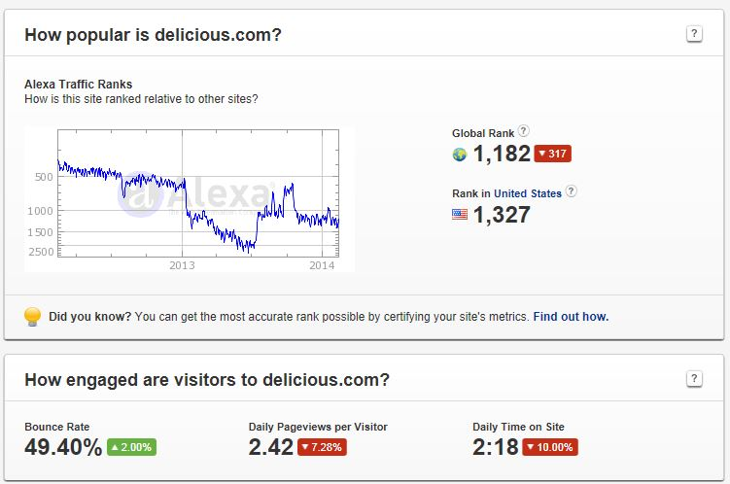
Delicious needs to bust some moves to turn this around
Flickr
Oddly enough Flickr stats look like a mirror of what is happening to Delicious. A horrific decline from 2012 to mid 2013 was followed by a rapid increase around mid 2013. As with Delicious the gains upward were short-lived and Flickr currently shows an uncomfortable drop but has leveled off for the time being. Due to the volatile and large downward movements of Flickr in the last 12 plus months we anticipate them to be at risk of further drops in 2014 although it is just as possible they could have some stability with no major upticks.
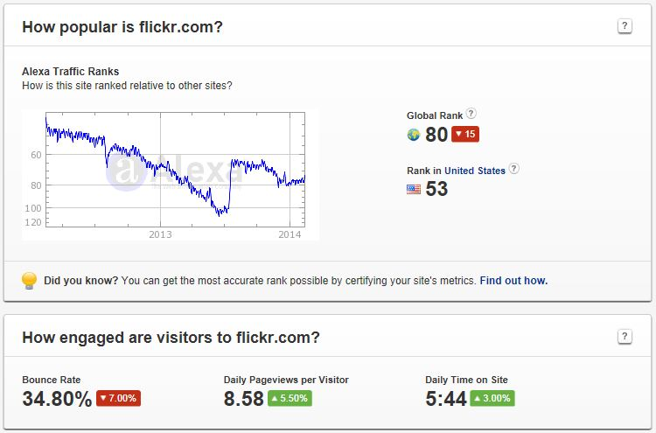
Flickr needs to turn this around before it gets any worse
Merchant Circle
Merchant Circle has been under our watchful eye for some time now and we are very sad to report that they have been in a continuous and horrific decline for a long time now. It appears as if they suffer from competition from Manta, Foursquare and others while simultaneously suffering from lack of any recent, modern updates.
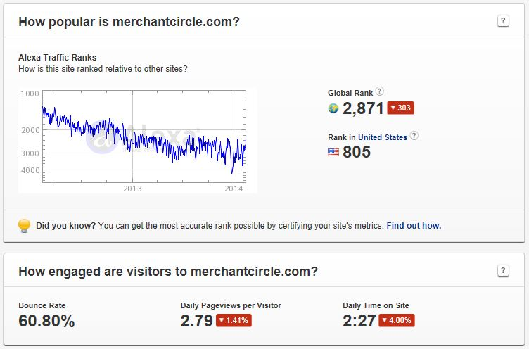
The once mighty Merchant Circle appears to be in some trouble for 2014

Impact Social Media is located in Kansas City and we are specialists at Social Media Development, Social Media Management, Social Media Marketing and Social Media API’s - Integration. We also have the capability to build you your own social network that would be just like Facebook or Twitter albeit it would be incorporated into your website with matching branding and theme.
We are adept at developing, managing and marketing any of your social media pages. With our in-depth knowledge of all of the available platforms we are uniquely qualified to steer you to the social networks which will be of the greatest benefit to you. Each social network is different and each one is suited for a different niche.
Once the best social networks for marketing your target audience are determined, we can get started building your social media pages with aesthetically pleasing graphics and keyword targeted content. If you already have social media pages but are looking for professional social media management and marketing we can take care of that as well.
For a very affordable cost we can do all of your social media development, social media posting, social media marketing, fan base engagement and we will also seek out and work at connecting you with other social media pages and users that are of benefit to your business marketing goals.
We also want you to know that we are very experienced in implementing social media interconnectivity for your website. If you need clickable icons that link to your social page, clickable buttons for sharing your content, clickable buttons that allow users to like, follow or share you website page or content, fancy social media widgets or specialized Facebook tabs we can provide whatever you need.
If you would like to learn more about our professional social media services take a moment to visit http://impactsocialmedia.net/kansas-city-social-media/
Whether you are local here in Kansas City or if you are anywhere else in the world and you are interested in using social media to promote your business or organization get in touch with us and let us show you how we can IMPACT your social media! You can email us at sales@impactsocialmedia.net or if you prefer give us a call at 816-743-0525.
You can access our Google+ social media community at:
https://plus.google.com/u/0/b/112720536143524208087/communities/107634818220798545213
You can access our VK social media community at:
http://vk.com/club63546836
You can access our Odnoklassniki social media group at:
http://www.odnoklassniki.ru/group/51781951488145

If you have questions or need assistance you can email us at:
sales@impactsocialmedia.net

You can also call us at 816-743-0525

Got Impact? Get Impact! How? With Impact Social Media!

