Got Impact? Get Impact! How? With Impact Social Media!
Follow Us!

Visit us on the web: http://impactsocialmedia.net/

How To Setup A Domain Name

How To Setup A Domain
URL: http://impactsocialmedia.net/setting-up-a-domain/how-to-setup-a-domain/
Description: Setting up a domain will have to be done any time you purchase or transfer a domain name. The procedure is fairly simple and only takes a few moments. The process involves inserting the contact information and name server information as well as setting the auto-renew, domain locking and domain privacy. If you need assistance with your domain name setup you can contact us and we will be happy to assist you. If you choose to do it yourself we suggest you make use of this handy guideline.

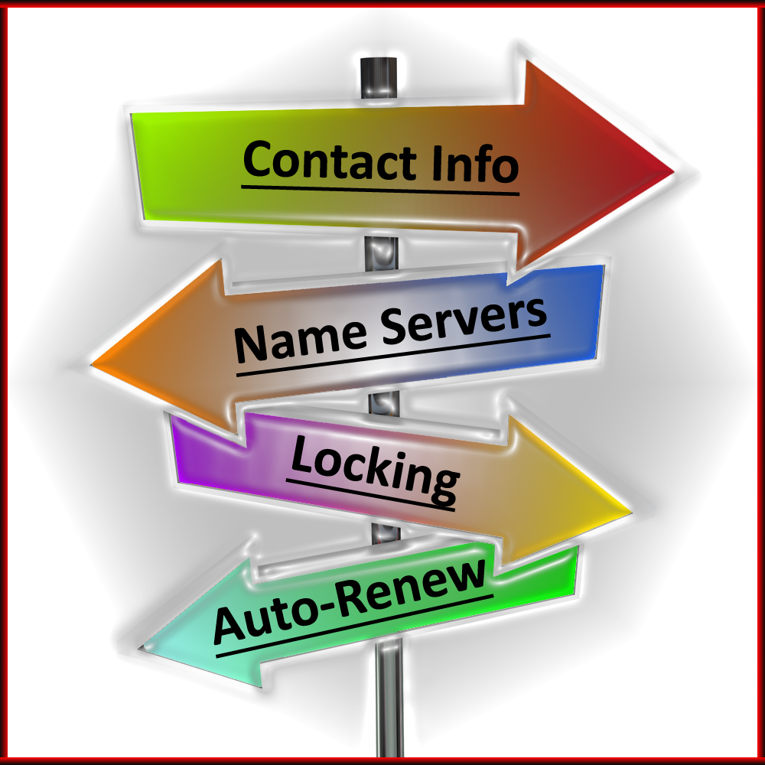
Domain Name Setup

I. Domain Name Setup Guide
1. Helpful resources
We have provided a lot of helpful resources when it comes to all things concerning domain names. You are more than welcome to make use of some or all of these resources at any time.
You can find our helpful online video tutorials at this URL:
http://impacthelp.impactsocialmedia.net/
You can find our web page about What is a domain name at this URL:
http://impactsocialmedia.net/domain-names/what-is-a-domain-name/
You can find our web page about Domain name registration and domain hosting at this URL:
http://impactsocialmedia.net/domain-name-registration/domain-hosting/
You can find our web page about Who owns a domain name and buy a website at this URL:
http://impactsocialmedia.net/who-owns-domain/buy-a-website/
You can find our web page about Choosing a domain name at this URL:
http://impactsocialmedia.net/choosing-a-domain-name/how-to-choose-a-domain-name/
You can find our web page about How to transfer a domain name at this URL:
http://impactsocialmedia.net/domain-transfer/how-to-transfer-a-domain-name/
2. Setting up a domain and DNS
Upon purchasing a domain name there are a variety of steps that must be taken and we are going to cover those now. Upon purchase, you should have a login ID and password that will allow you secure access to manage your domain name(s). Be sure to store these in a good place for safe keeping.
The first step will be to record all of the contact details for the domain name. This is a critical step as this will make a legal record of who the owner is and how to contact them. It will also allow for the recording of other points of contact for the Administrative, Technical and Billing. Be sure to include your properly spelled full name, full address, email, company name if applicable and your telephone number.
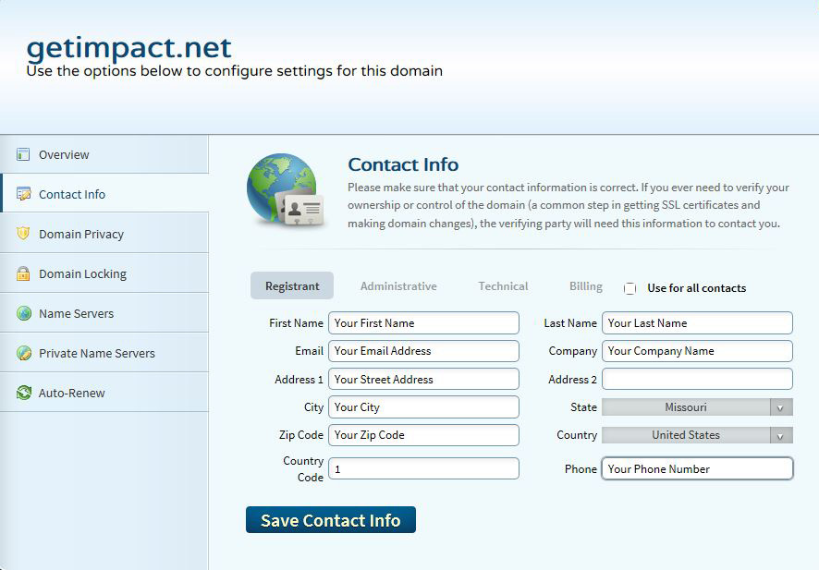
Insert the contact information for all of the points of contact
Note: Be sure to keep this information current! If your contact information becomes invalid it may be impossible to notify you of upcoming domain name expiration. One trick is to use alternate emails and alternate phone numbers for the different points of contact. Place one phone number and email as the Registrant, a different email and phone number for the Administrative and if possible even one more alternate email and phone number under the Technical and Billing contacts. This improves the odds of it being possible to contact you in case you need to be notified.
The second step is to set the domain privacy to ON or OFF. If turned OFF your contact information will be open to public view. If turned ON your contact information will be hidden from public view. Keep in mind that you may or may not be required to pay an extra fee for turning ON domain privacy.
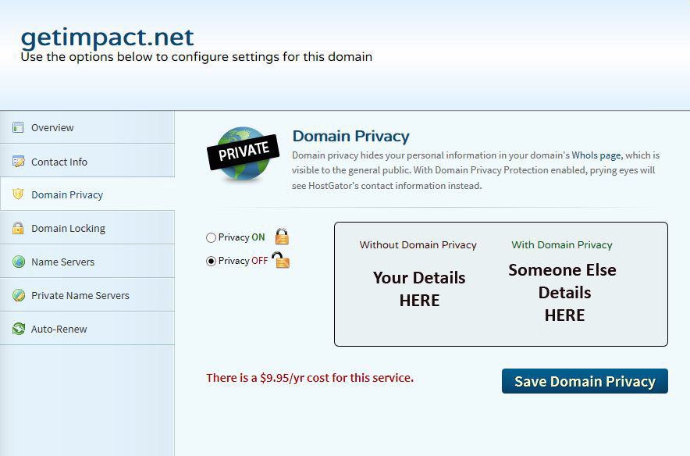
Domain privacy replaces your contact details with someone else’s
The third step is to set the domain locking feature. The domain locking feature helps to prevent third parties from trying to edit, transfer or delete your domain name without permission. I always recommend turning the domain locking ON and you can simply turn it OFF if and when you need to transfer or make changes.
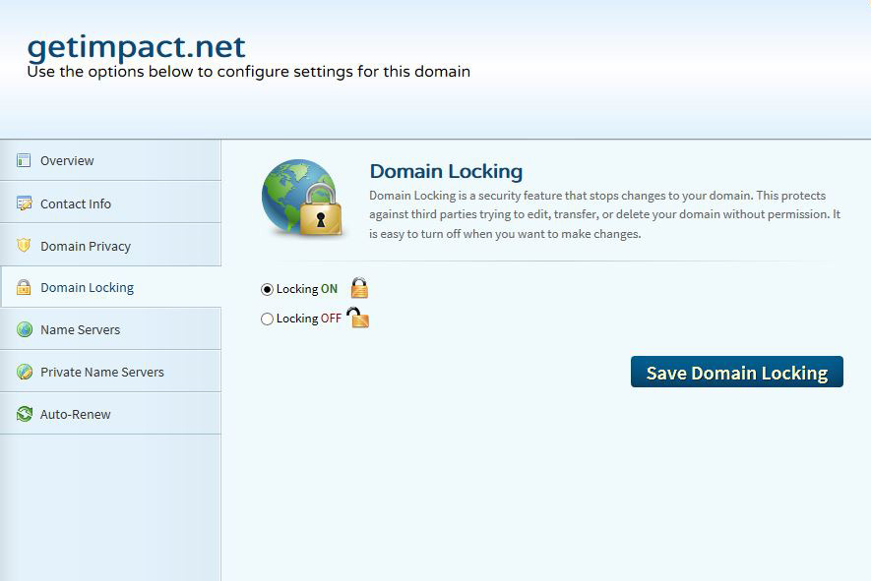
Always set the domain locking ON for protection
The fourth step is to setup the DNS or “name servers.” You will have to determine your domain servers by contacting your hosting company and they will provide this information to you.
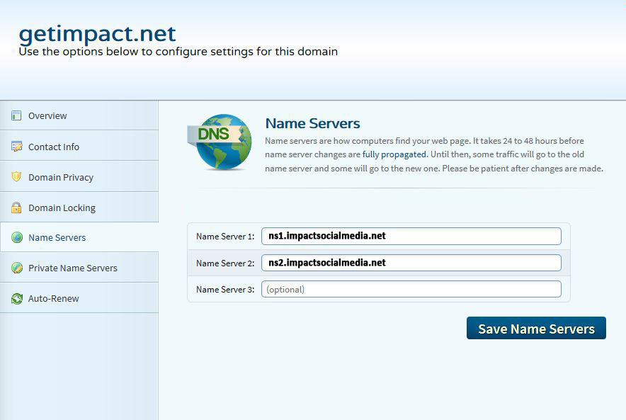
Find out your name server details and enter them here
An example of a name server might be ns1.impactsocialmedia.net or ns2.impactsocialmedia.net. You will probably have two or more name servers in case the first one fails. This is to provide a backup name server in the event something was to go wrong with the first one.
Keep in mind that when you change the DNS or name server settings it may take up to 24 hours for these changes to propagate across the web. So don’t be alarmed if your domain name is not immediately available. If it does not become available within 24 hours this is a good indication you may have the name server settings wrong and you will need to investigate further.
The final and fifth step is to set the domain name auto-renew. This setting determines if your domain name will be allowed to expire or if it will be automatically renewed with no intervention on your part. Unless for some reason you have a temporary website or a website that you want to terminate I always recommend setting this option to auto-renew ON. This will act as a safeguard to prevent termination or service interruption for your domain name.
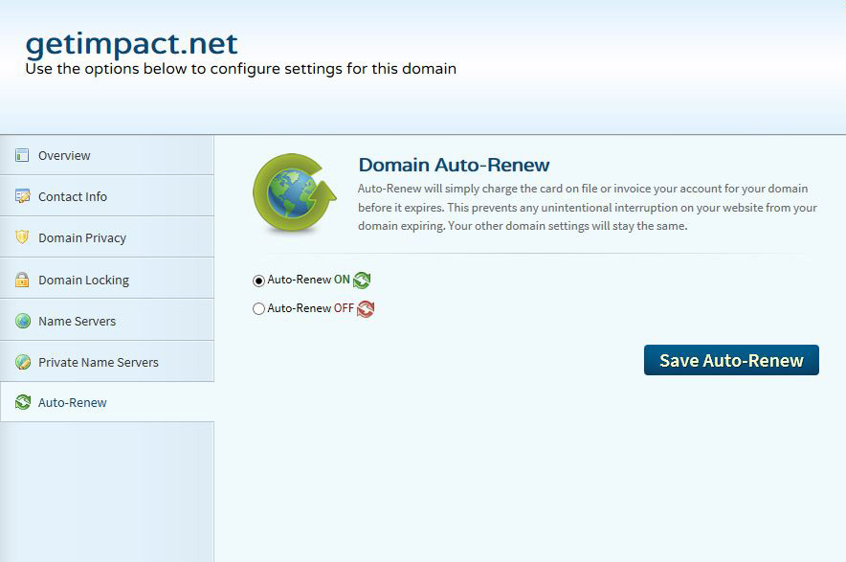
Set the Auto-Renew ON to prevent your domain name from expiring

Impact Social Media

If you are in need of professional assistance for domain name setup we would be happy to assist you. We do offer complete services to research, negotiate and transact any type of domain purchase be it new, existing or pusher. We are also expert at setting up, managing and transferring domain names. If you need assistance with any of these items just let us know.
Your domain name is one of the most important elements of your entire digital presence and we want to be sure that you get it right the first time. Contact us today if you need professional assistance.

If you have questions or need assistance you can email us at:
sales@impactsocialmedia.net

You can also call us at 816-743-0525

Got Impact? Get Impact! How? With Impact Social Media!

