Got Impact? Get Impact! How? With Impact Social Media!
Follow Us!

Visit us on the web: http://impactsocialmedia.net/

How To Transfer A Domain Name

How To Transfer A Domain Name
URL: http://impactsocialmedia.net/domain-transfer/how-to-transfer-a-domain-name/
Description: Domain transfer will have to be done any time you purchase an existing domain name from an owner or whenever you move a domain name from one registrar to another. The procedure is fairly simple and can be accomplished fairly quickly. If you need assistance with your domain name transfer you can contact us and we will be happy to assist you. If you choose to do it yourself we suggest you make use of this handy guideline and our online video tutorials.

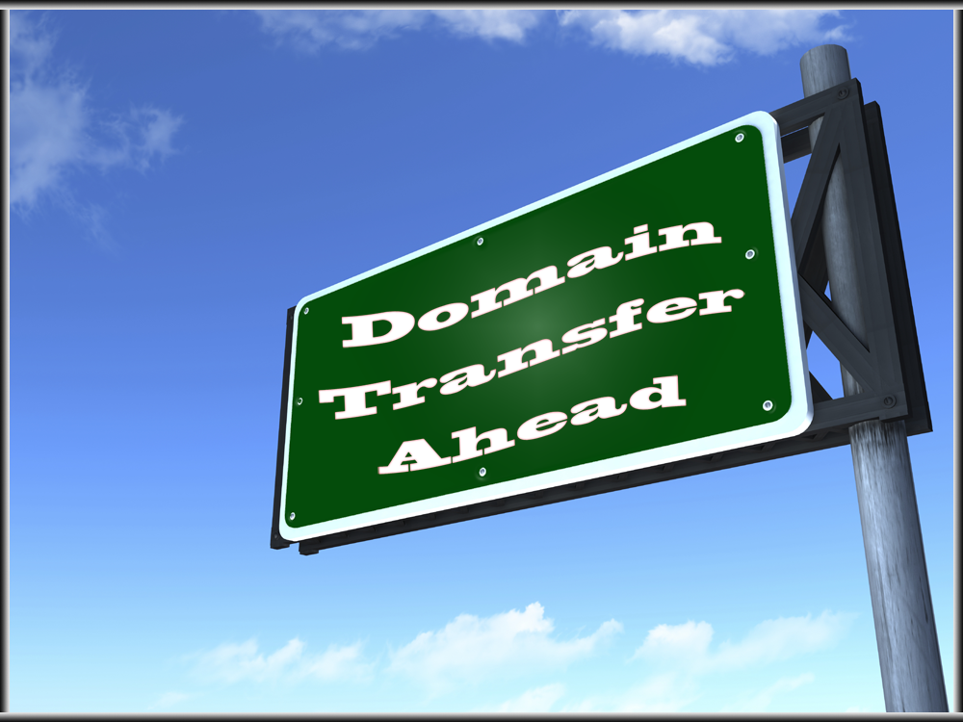
Domain Name Transfer

I. Domain Transfer Guide
1. Helpful resources
We have provided a lot of helpful resources when it comes to all things concerning domain names. You are more than welcome to make use of some or all of these resources at any time.
You can find all of our helpful online video tutorials at this URL: http://impacthelp.impactsocialmedia.net/

You can find our web page What is a domain name at this URL: http://impactsocialmedia.net/domain-names/what-is-a-domain-name/

You can find our web page about Domain name registration and domain hosting at this URL: http://impactsocialmedia.net/domain-name-registration/domain-hosting/

You can find our web page about Who owns a domain and buy a website at this URL: http://impactsocialmedia.net/who-owns-domain/buy-a-website/

You can find our web page about Choosing a domain name and how to choose a domain name at this URL: http://impactsocialmedia.net/choosing-a-domain-name/how-to-choose-a-domain-name/

You can find our web page about Setting up a domain and how to setup a domain at this URL: http://impactsocialmedia.net/setting-up-a-domain/how-to-setup-a-domain/

2. Transferring domain names
When you transfer a domain name this can mean transfer of ownership and/or transfer to a different registrar. Regardless of which scenario the process is essentially the same.
The first step will be to make preparations for the transfer. This will include turning off domain locking and acquiring the EPP Key. The second step will be to contact one or both registrars so that you can communicate to them what is transpiring. The registrars will handle the literal transfer of the name.
If you are transferring due to a purchase you may have to provide a copy of the signed domain purchase agreement. It is also very likely the registrar will have to verify the transfer with the existing owner. Keep in mind that a registrar might not transfer a domain within 60 days after registrant information has been changed.
Once the transfer is complete you will want to go through each step for the entire domain setup procedure. You can find our web page about domain setup at this URL: http://impactsocialmedia.net/setting-up-a-domain/how-to-setup-a-domain/

3. Online video tutorials for domain transfer
Our domain transfer video for Enom is at this URL: http://impacthelp.impactsocialmedia.net/inc/content.php?q=/videos/domain-management/enom/m/Preparing-a-domain-for-transfer-from-eNom.com.php

Our domain transfer video for GoDaddy is at this URL: http://impacthelp.impactsocialmedia.net/inc/content.php?q=/videos/domain-management/godaddy/m/Preparing-a-domain-for-transfer-from-GoDaddy.com.php

Our domain transfer video for Network Solutions is at this URL: http://impacthelp.impactsocialmedia.net/inc/content.php?q=/videos/domain-management/networksolutions/m/Preparing-a-domain-for-transfer-from-NetworkSolutions.com.php

Our domain transfer video for Register is at this URL: http://impacthelp.impactsocialmedia.net/inc/content.php?q=/videos/domain-management/register/m/Preparing-a-domain-for-transfer-from-Register.com.php

Our domain transfer video for Yahoo is at this URL: http://impacthelp.impactsocialmedia.net/inc/content.php?q=/videos/domain-management/yahoo/m/Preparing-a-domain-for-transfer-from-Yahoo.com.php

Our domain transfer video for Dotster is at this URL: http://impacthelp.impactsocialmedia.net/inc/content.php?q=/videos/domain-management/dotster/m/Preparing-a-domain-for-transfer-from-Dotster.com.php

Our domain transfer video for NameCheap is at this URL: http://impacthelp.impactsocialmedia.net/inc/content.php?q=/videos/domain-management/namecheap/m/Preparing-a-domain-for-transfer-from-NameCheap.com.php

Our domain transfer video for 1and1 is at this URL: http://impacthelp.impactsocialmedia.net/inc/content.php?q=/videos/domain-management/1and1/m/Preparing-a-domain-for-transfer-from-1and1.com.php

Our domain transfer video for 123-Reg is at this URL: http://impacthelp.impactsocialmedia.net/inc/content.php?q=/videos/domain-management/123reg/m/Preparing-a-domain-for-transfer-from-123reg.co.uk.php

Impact Social Media

If you are in need of professional assistance for domain name transfer we would be happy to assist you. We also offer complete services to research, negotiate and transact any type of domain purchase be it new, existing or pusher. We are also expert at setting up, managing and transferring domain names. If you need assistance with any of these items just let us know.
Your domain name is one of the most important elements of your entire digital presence and we want to be sure that you get it right the first time. Contact us today if you’re in need of professional assistance.
If you would like to learn more about our affordable managed web hosting services for small business take a look at http://impactsocialmedia.net/web-hosting/

If you have questions or need assistance you can email us at:
sales@impactsocialmedia.net

You can also call us at 816-743-0525

Got Impact? Get Impact! How? With Impact Social Media!

