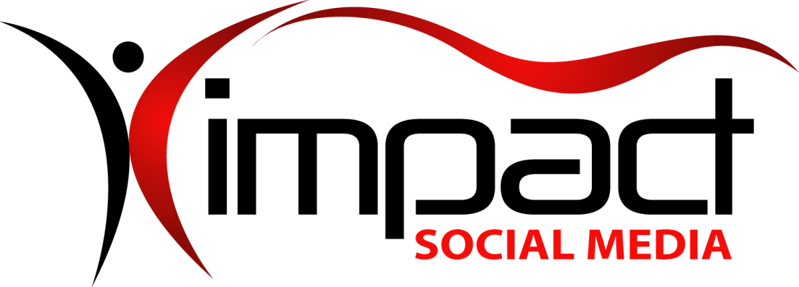
Got Impact? Get Impact! How? With Impact Social Media!
Follow Us!

Visit us on the web: http://impactsocialmedia.net/

Impact Social Media

Return Policy

Impact Social Media – Return Policy URL: http://impactsocialmedia.net/returns-policy/

Impact Social Media Return Policy
Like many retailers, we guarantee our products and services; if an item or performed service hasn’t met your expectations, you can request a modification or refund. Unlike most retailers, we also guarantee the product or service selection advice offered through our website and staff; if an item or service you’ve purchased based on this advice turns out to be unsuitable, you can request for a modification or refund. In either case, simply contact us to discuss the problem and options for modification, refund or credit.
Our utmost priority is that your experience with us is pleasant and that you are completely satisfied with the transaction. We sincerely appreciate your business and will work with you to rectify any issues that might arise. This return policy is designed to protect your investment with us and to also give you peace of mind when choosing our products and services.
If you have any questions about or need to make use of our return policy, please choose one of the following options which is most convenient for you:
- Call our customer support department at 816-743-0525
- Email us at sales@impactsocialmedia.net
- Submit a support ticket at our customer portal
- Send mail to or visit our office at 4913 SW Gull Point Dr., Lee’s Summit, MO. 64082

