Got Impact? Get Impact! How? With Impact Social Media!
Follow Us!

Visit us on the web: www.impactsocialmedia.net

Impact Social Media Web Hosting
Link to Impact Social Media Web Hosting: http://impactsocialmedia.net/web-hosting/
Description: Website hosting is a requirement for any website or application that will be seen by viewers of the World Wide Web. It can be a daunting task for a startup company, business owner or organization to decide which hosting company to use. This is because there are so many to choose from and they all have a wide variety of claims and offers. For that reason, we would like to have a moment of your time to introduce ourselves and the details of our web hosting. We are confident that once you become aware of our offerings you will find us to be one of the best web hosting options available to you anywhere.

Impact Social Media Web Hosting Table Of Contents
Contents
I. Why Impact? 3
1. Professional and personalized service 4
2. Our pricing gives more bangs for your buck 4
3. Web hosting with babysitting - websitting 4
4. Focused on your unique needs 5
5. Eco-friendly green web hosting 6
6. No length of term requirements 6
7. Extensive amount of features are included 6
8. We give back to the community 6
II. Types of websites that we host 7
III. Types of platforms that we host 8
IV. What our hosting plans include 9
V. Pricing details 11

Eco-friendly GREEN web hosting

Why Impact?

- Professional and personalized service
- Our pricing = get more bangs for your buck
- Web hosting with babysitting websitting
- Focused on your unique needs
- Eco-friendly green web servers
- No length of term requirements
- Extensive features included

Professional and personalized service
We take pride in offering professional and personalized service. We are geared towards startup companies and small to medium sized businesses and organizations. This allows us to have a special focus on your unique needs.
When you host with us you will not be like a grain of sand on the beach. Instead, you will be given service as part of our family of hosting clients. We are well aware of the many available options to you and so we strive to give you a customer experience that will keep you hosting with us long-term.

Our pricing gives more bangs for your buck
We have done a great deal of industry research concerning the various pricing platforms that are available. The industry displays a very broad spectrum of pricing that ranges all the way from free to high-end expensive.
In the process of doing our research, we discovered that while there is a massive multitude of hosting providers, few of them are truly geared for the unique needs of startup companies and smaller sized businesses and organizations. This is because most hosting companies are focused on the do-it-yourself philosophy.
This can be great if you are looking for the lowest possible price and are already a webmaster and have the experience needed for such an undertaking. Problem is, few of the clients we focus on fit in this category. Most of them do not have the expertise to handle all of the tasks associated with do-it-yourself web hosting.
Our strategy gives you the most bang for your buck because we go against the grain of do-it-yourself hosting. Our hosting includes a full time babysitter or “websitter” for your hosted site! Let us explain our websitting.

Web hosting with babysitting - websitting
Our typical clients have little to no knowledge of things like directory security, DNS zones, DOS attacks, hot linking, name servers, robots.txt, suspicious activity, tar backups, traffic statistics, URL redirects, etc., etc.
Past that, our clients are better served to use their true talents to stay focused on the operations and success of their own business. This is precisely why Impact Social Media has developed our unique hosting program that we call “websitting.”
Many people do not realize that a website cannot merely exist on a webserver with no monitoring, intervention or maintenance. Just like you cannot leave an infant without a babysitter you should also not abandon your website without a websitter.
In order to provide a targeted service that best fits the needs of our clients; we have developed a unique web hosting - websitting arrangement. We include the routine tasks, monitoring and ongoing maintenance of your website within your hosting fees.
Our hosting plan includes monitoring your website for 401 errors, suspicious and malicious activity, hot linking, DOS (denial of service) and other threats. Any detected problems or threats will be neutralized and you will be made aware of the details.
Our hosting also includes routine maintenance requirements for site backups and other items. If your site is static you will receive an emailed backup copy monthly. If your site is dynamic you will receive an emailed backup copy daily, weekly or bi-weekly depending on the frequency of your changes.
Last but not least, our hosting includes a monthly IMPACT report. The IMPACT report will be emailed to you and will give you a very detailed representation of the traffic statistics and data at your website. This will help you to see what is going on with your traffic and will also aid you in making decisions to improve your site.

Focused on your unique needs
Impact Social Media is focused on startup companies and small to medium sized businesses and organizations. We have our roots in entrepreneurial ventures and we are intimately familiar with the unique concerns and needs of these particular groups.
This makes us uniquely qualified to cater to your specific needs. Our strategies and methodologies are formed within a framework that encompasses everything that is most important to you. Truth is, we have a lot in common with you and this gives us special insight.

Eco-friendly green web hosting
Another benefit of hosting with us is that you are using eco-friendly green web servers. A typical server produces just about the same emissions as a 15mpg SUV! Because we care about the environment we offset this by using web servers that are 130% wind powered. We think locally and we act globally. Our environment is important now and for future generations.

No length of term requirements
We feel that the best way to keep you onboard is with superior service instead of binding you in with contracts and fine print. We also realize that things change and for whatever reason it may be in your best interest to move or terminate your hosting. It is our desire that you are free to do this with no contractual obligations as your best interests are our top priority.

Extensive amount of features are included
Our feature packed hosting does not just include hosting, websitting and green servers. It also includes an overwhelming quantity of impressive features. All of these additional features are provided to ensure that your hosting will provide you with anything you could possibly need.
Our many features are also geared to your specific needs. Many of them are especially suited for startup companies and small to medium sized businesses. For instance, our online video tutorials, mailing lists, auto-email forwarders, auto-email responses, website templates, QuickInstall and Fantastico Deluxe are all focused directly on your needs.
We can host just about any type of website or website platform you can think of. Please take a look at the extensive listing of website types and website platforms that we accommodate. Also, be sure to take a look at the complete itemized listing of our many hosting features that will be shown in section IV.

We give back to the community
We are passionate about doing what we can to give back to our community. We offer free services to 501c3’s for the purpose of aiding humanitarian causes. We also offer free services to those in need of economic empowerment.
We have also created the Impact Education Program. This program allows college students to have a free web hosting account. This account gives them complete use of a full blown web server with all of the bells and whistles.
The Impact Education Program enables college students to experiment, learn and propel their education at no cost to them. We also allow them to continue with the arrangement after graduation. This allows them to hone their skills, display resumes and to show off examples of their work when seeking employment.
In summary, we would like to challenge you to closely examine all of the features and benefits that are included with our hosting. We are very confident that you will be hard pressed to find a competitor who offers this many features with websitting included. The purpose of so many features is to give you more bangs for your buck as well as a greater deal of flexibility.
Now we would like you to take a minute to look over the types of websites and website platforms that we host. Also, take some time to look closely at our entire included web hosting features.

Types of websites that we host

- HTML-CSS (Hyper Text Markup Language, Cascading Style Sheets)
- Java, Visual Basic, C, C++, C#, Perl, PHP, Python and others
- Mobile HTML5 – CSS3
- Ruby on Rails
- ASP NET (Active Server Pages)
- Dynamic-Scripted
- Flash
- Databases (MySQL, Access and PostgreSQL)
- Applications
- LAMP (Linux, Apache, MySQL, PHP)
- WAMP (Windows, Apache, MySQL, PHP)
- SSL (Secure Socket Layer)
- Blogs
- Calendars
- Chat
- Classifieds
- CMS (Content Management Systems)
- Community Building
- CRM (Customer Relationship Management)
- Dashboards-Business Intelligence
- Discussion Boards
- E-Commerce
- Educational
- E-Portfolio
- Galleries
- Guestbook
- Polls
- Project Management
- Wiki

Types of platforms that we host

- 4Images Gallery
- AccountLab Plus
- B2evolution
- Coppermine Photo Gallery
- Crafty Syntax Live Help
- CubeCart
- Dew-NewPHP Links
- dotProject
- Drupal
- FAQMasterFles
- Gallery
- Geeklog
- Help Center Live
- Joomla
- LimeSurvey
- Mambo
- Moodle
- Noah’s Classifieds
- Nucleus
- Open-Realty
- OS Commerce
- OsTicket
- OxWall
- PerlDesk
- Php COIN
- PHP Support Tickets
- PHPauction
- phpBB
- phpESP
- PHPlist
- PHP-Nuke
- PHProjekt
- phpWCMS
- phpWebSite
- PhpWiki
- Siteframe
- SMF
- Support Logic Helpdesk
- Support Services Manager
- TikiWiki
- Typo3
- WHMCS
- WordPress
- Xoops
- YaBB
- Zen Cart
- Zikula

What our hosting plans include

- Eco-friendly green web servers
- 99.9% uptime guarantee
- Monthly IMPACT report
- cPanel interface
- Comprehensive online video tutorials
- 24-7 Tech support
- Online payment gateway
- Online customer portal
- Online support ticket system
- 4,000+ Free website templates
- Free site building tools
- Unlimited email accounts
- Spam Assassin for email
- Email forwarders
- Email auto-responders
- Mailing lists
- Email tracing
- Automated backups
- Unlimited FTP access
- Webalizer tracking statistics
- Raw access logs
- Error logs
- Awstats tracking statistics
- Google analytics integration
- Password protect for directories
- IP deny manager
- Hotlinks protection
- GnuPG keys
- Unlimited Subdomains
- Unlimited Addon domains
- Unlimited Parked domains
- Server level URL redirects
- Private name servers
- DNS zone editor
- Unlimited MySQL databases
- MySQL database wizard
- phpMyAdmin
- Remote MySQL
- Basekit Sitebuilder
- CGI center and scripts
- QuickInstall
- Perl Modules
- PHP Pear Packages
- PHP Configuration
- Ruby Gems
- Ruby on Rails
- Website optimizer
- Fantastico Deluxe
- Apache handlers
- Image manager
- Index manager
- Cron jobs
- Network tools
- Frontpage extensions
- Mime types
- Cloudflare
- Quick file uploads
- Extensive online video tutorials

Pricing details

- Static HTML-CSS @ $9.95 per month
- Dynamic-Scripted @ $19.95 per month
- Disk space up to 1,000 MB ***
- Monthly bandwidth up to 5,000 MB ***
- Unlimited FTP accounts
- Unlimited Email accounts
- Unlimited Email lists
- Unlimited MySQL databases
- Unlimited Subdomains
- Unlimited Parked domains
- Unlimited Addon domains
- Includes babysitting - websitting as described previously
- Includes monthly emailed IMPACT report
- Includes emailed backup of all data
- Includes threat monitoring and neutralization
- Includes ongoing and routine maintenance
*** More disk space and monthly bandwidth is available for an up charge, however the vast majority of websites will fit well within the range above.

Click HERE to view our complete pricing guide online.
Click HERE to read about our web design information.
Click HERE to read about our graphics design information.
Click HERE to learn all about website types and platforms.
Click HERE to learn all about domain names.
Click HERE to learn all about logos.
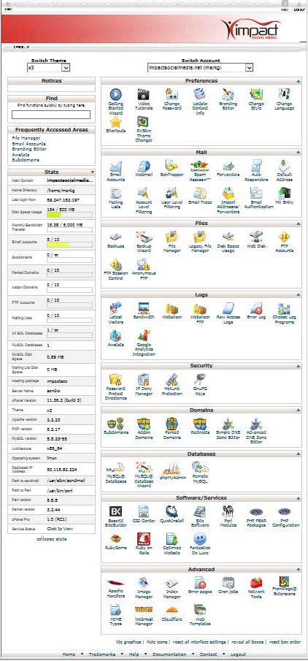
Our full featured cPanel interface
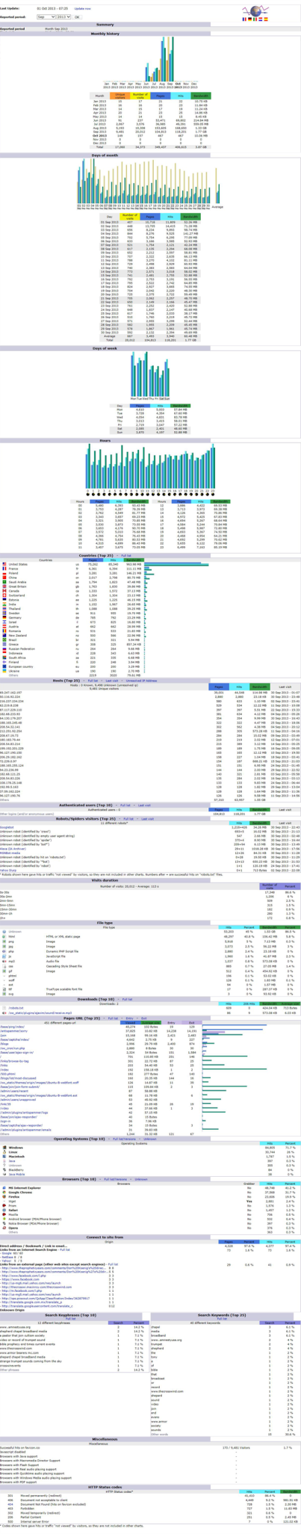
Comprehensive IMPACT reports let you know what’s going on

Impact Social Media specializes in targeted web hosting services that are uniquely geared for startup companies and small to medium sized businesses and organizations. If you have questions or need webhosting contact us today and let us show you why we are called Impact Social Media.

You can access our client portal at the following URL:
http://impactsocialmedia.net/whmcs/

You can access our online video tutorials at the following URL:
http://impacthelp.impactsocialmedia.net/

You can access our webpage for website development at the following URL:
http://impactsocialmedia.net/web-design/

If you have questions or need assistance you can email us at:
sales@impactsocialmedia.net

You can also call us at 816-743-0525

Got Impact? Get Impact! How? With Impact Social Media!

