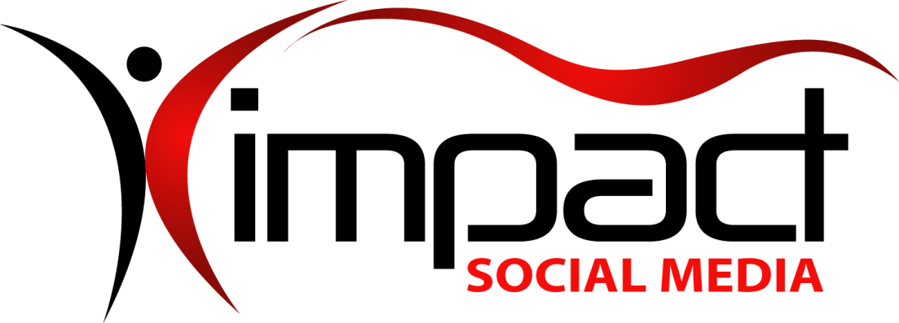
Got Impact? Get Impact! How? With Impact Social Media!
Follow Us!

Visit us on the web: http://impactsocialmedia.net/

Impact Social Media Domain Name Purchasing
Link to Domain Name Purchasing: http://impactsocialmedia.net/domains/purchasing/
Description: Domain name purchasing will be required once you determine the name you want. There are many options for you to purchase domain names as there are many online suppliers. Nearly all online suppliers work on the do-it-yourself premises. Basically they sell you a domain name and then you are on your own. At Impact Social Media we don’t just sell you a domain name but we include every last thing that goes along with it. This means we handle the purchase, setup, and ongoing maintenance all included in the purchase price. This includes name server DNS setup and changes, contact information setup and maintenance, auto-renew setup, locking setup and privacy setup.
Impact Social Media Domain Purchasing Table Of Contents
Contents
I. Domain Name Purchasing Overview 2
1. Why use us? 2
2. What our price includes 3
II. Domain Name Pricing Schedule 4
1. Domain name pricing table 4

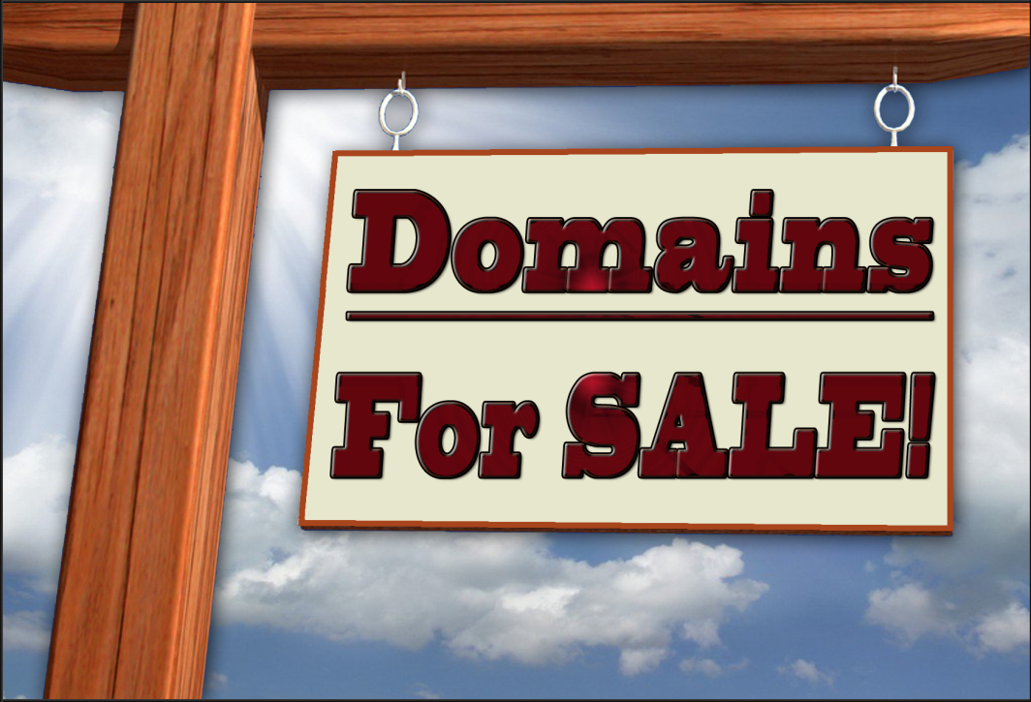

Domain Name Purchasing Overview

Why use us?
There are countless choices for places to buy a domain name. The question is, “What makes Impact Social Media different and why should you use us?”
One thing that makes us very different is that we are focused on startup companies and small to medium sized businesses and organizations. We are keenly aware of your needs and concerns. This is why we go against the industry standard by offering the opposite of a do-it-yourself domain purchasing approach.
We don’t just sell you a domain name and then leave you to your own devices. Instead, we also take care of every last detail that goes along with it. We also offer personalized service as in a real live person that you can call up and talk to about anything that is on your mind.
When you purchase a domain name from us the first thing we do is take care of any and all of the setup needs. This means we will contact your hosting company to determine your name server configuration details. We then setup your name server entries and then do testing to make sure all is well. If you need website hosting we offer those services as well.
The next thing we do is to take care of all of your domain contact information. When we do this we also insert an alternate email address to our tech support department. This helps to protect you in the event you fail to get a notification email on something critical concerning your domain name.
The next thing we do is setup your domain locking, auto-renew setting and privacy settings. Once all of the setup is complete we are still here for you and will be at the ready should you have any questions, need assistance or wish to change your name server settings or contact information.
Also, we will keep tabs on your domain name and periodically check it to make sure that the domain locking, auto-renew and any other important items are all okay. Lastly, we will keep track of your domain name expiration and will contact you via telephone and email so what we can make sure your domain name does not expire.
Essentially, when you buy a domain name from us you are also getting complete domain management and tech support services. You could say we become the babysitter for your domain name and all of its needs! This means you can concentrate on running your business by delegating the responsibility of your domain name management to Impact Social Media.

What our price includes
As already mentioned, our pricing includes your domain name purchase plus many additional beneficial features. Most all of our clients have little to no knowledge of all the processes required to setup and manage a domain name. Besides that, our clients are better served to focus their talents and energy on the task of running their business operation.
Take a look at what our domain name pricing includes:
- Your domain name purchase
- Determining your required DNS settings
- Setup of your DNS settings
- Testing of your DNS settings
- Setup of all your domain contact information
- Providing alternate email to protect you
- Setup of auto-renew feature
- Setup of domain locking feature
- Setup of domain privacy (if used)
- Quarterly checks to make sure everything is ok
- Online and/or telephone support
- Future DNS setting changes included
- Future contact information changes included
- We track your domain expiration and notify you

Domain Name Pricing Schedule

Domain name pricing table
Item | Price | Rate
.BIZ Purchase | $19.95 | Per Year
.BIZ Transfer | $12.95 | Each
.CO Purchase | $36.95 | Per Year
.CO Transfer | $12.95 | Each
.COM Purchase | $19.95 | Per Year
.COM Transfer | $12.95 | Each
.INFO Purchase | $19.95 | Per Year
.INFO Transfer | $12.95 | Each
.ME Purchase | $21.95 | Per Year
.ME Transfer | $14.95 | Each
.NET Purchase | $19.95 | Per Year
.NET Transfer | $12.95 | Each
.ORG Purchase | $19.95 | Per Year
.ORG Transfer | $12.95 | Each
For any domain types or domain services not listed here
you can contact us and we will be happy to assist you.

If you are in need of professional assistance for domain name purchasing, negotiated purchases, setup, management or transfer we would be happy to earn your business. We offer complete services for domain name purchasing and domain name negotiated purchases. We are also expert at researching, setting up, managing and transferring domain names.
Your domain name is one of the most important elements of your entire digital presence and we want to be sure that you get it right the first time. Contact us today and let us show you why we are called Impact Social Media!

If you have questions or need assistance you can email us at:
sales@impactsocialmedia.net
You can also call us at 816-743-0525

Got Impact? Get Impact! How? With Impact Social Media!

