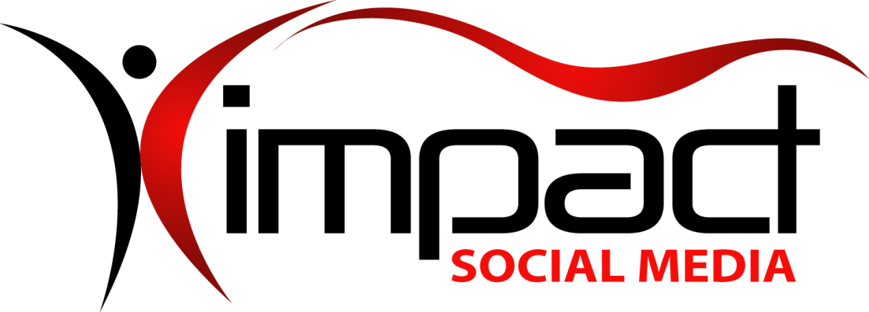
Got Impact? Get Impact! How? With Impact Social Media!
Follow Us!

Visit us on the web: http://impactsocialmedia.net/

Who Owns Domain | Buy A Website

Who Owns Domain | Buy A Website
URL: http://impactsocialmedia.net/who-owns-domain/buy-a-website/
Description: Domain name purchase negotiations occur when you seek to buy a domain name that is already owned by someone else. There is more than one way to approach this and not all paths will lead to success. One must also be on the lookout for those who would seek to use this opportunity against you. We offer complete domain negotiation services and we will work tirelessly to obtain you the best possible deal. If you choose to do your own negotiating we recommend that you make use of this handy guideline which may help you in avoiding some common mistakes.

Impact Social Media For Domain Name Negotiations

I. Negotiated Domain Purchase Overview
1. What is a negotiated domain purchase?
A negotiated domain purchase is when somebody already owns the domain you desire and therefore you are required to negotiate a purchase and transfer agreement. The negotiations could involve a random owner, a domain investor or even a cybersquatter.
It is important to understand the dynamics of these negotiations if you wish to obtain an already owned domain name. There are some basic guidelines that could be considered the same as you would find with other types of negotiations. There are also some other considerations that are unique to domain names.
Essentially the process involves research, contacting the owner, negotiating the terms and then finally the legal transfer. Keep in mind that a domain could literally be considered as “virtual real estate.” Therefore, different legalities and liabilities will apply to the entire process.
2. Why do a negotiated purchase?
As the internet continues to exponentially expand and grow it becomes more and more difficult to find a domain name that is not already taken. Part of this can be attributed to the size and growth of the internet. Also, part of it can be attributed to domain investors and cybersquatters. To put this into perspective it is a good idea to examine these staggering statistics which are provided by the leading industry expert Internet Live Stats;
The following data reflects global statistics. These statistics are courtesy of Internet Live Stats at http://www.internetlivestats.com/internet-users/
Total | New | Deleted | Transferred | Type
147,518,378 | 134,164 | 129,089 | 133,740 | All Types
111,245,438 | 105,247 | 98,207 | 103,437 | .COM
15,204,712 | 12,666 | 14,148 | 13,059 | .NET
10,393,852 | 8,091 | 6,928 | 8,437 | .ORG
6,206,194 | 5,496 | 6,187 | 5,798 | .INFO
2,614,646 | 1,425 | 1,847 | 1,709 | .BIZ
1,853,536 | 1,239 | 1,772 | 1,300 | .US
As you can see in the table above, 100’s of millions of domains are already owned and each day a massive quantity of domains are purchased, deleted and transferred! This is clearly a dynamic and rapidly changing market, especially where Dot COMs are concerned.
All of this means that as time moves forward, good domain names are more difficult to obtain while the potential of having to do a negotiated purchase also increases.
My best advice to you is this; if you are contemplating buying a domain name the sooner you do it the better your chances are. A domain that is available today may not be available tomorrow, next week or next month!
3. Do it yourself or hire it done?
We are not here to discourage you from a do-it-yourself approach. If you choose this path we understand and we have taken the time to provide you with some helpful information and tips.
If you prefer to turn this process over to a qualified professional we would be happy to assist you. We are adept at acquiring your dream domain and will utilize experience and techniques that can potentially save you money while also protecting you. In some cases we can actually save you enough money to cover our fees. At the same time, we are familiar with the liabilities and legalities and will leave no stone unturned in protecting you and your best interests.

II. Types Of Negotiated Domains
1. In use
The “in use” domain name is not only already owned but also being made use of. Also, this implies legitimate use as in a for real honest to goodness website. A domain-for-sale splash page or other pages like link farms or advertisements only do not count.
The in use domain name can pose the unique challenge of dealing with the existing owners time, investment and interests. While it is possible to negotiate a purchase for an in use domain you can also expect mixed results.
If the in use domain is very old and established or is very successful, you could be looking at having to offer a very large sum of money to obtain it. In these cases it is usually better to research for a good alternative domain name unless of course money is no object.
In other cases the in use domain is no big prize to the owner due to lack of interest, lack of success or lack of a pressing need. In these instances you may have a good chance at obtaining the domain name for a reasonable price.
2. Not in use
The “not in use” domain name is one that has no truly functional website located there. The not in use category includes the previously mentioned domain-for-sale splash page, link farm or advertisements only display.
The not in use domain has the advantage of lacking all the potential issues just mentioned concerning an in use domain. That being said, you could still find yourself getting mixed results in the negotiation process.
This is variable depending on whether you find yourself negotiating with a random owner vs. domain investor or cybersquatter. Your best chance of success usually lies with a not in use domain and a random owner. If you find yourself having to deal with a domain investor or cybersquatter things get exponentially more complex very quickly. It is always wise to do research and try to determine what type of an owner you will be dealing with. You can then devise a more targeted plan for moving forward with the process.

III. Types Of Sellers
1. Random owner
The random owner could be a person, business or organization. Most likely they once had or currently have some type of a website on display at the domain you wish to acquire. Not all random owners are created equal in that they have varying degrees of investment into a given domain as well as varying degrees of negotiation savvy.
As always, good research is very helpful before you make a move to approach them. You need to know various details to help gauge your approach method and those will be discussed under the “do your homework topic.” For negotiated domain purchases the typical best case scenario is a random owner with a domain name that is not in use.
2. Domain investor
The first thing I want to say is that the domain investor is not a form of evil but rather a business entity that seeks to generate profit just like any other business. Their core element is to buy low and sell high. They spend a great deal of time, energy and money thinking of good domain names and then buying them up.
The domain names that they acquire then become a potentially sellable commodity to anyone who might desire them. Domain investors tend to be a savvy breed and are well aware of the reasonable value of any particular domain name. They are legitimate in that they buy without the purposeful intent to prey on others as opposed to malicious types like cybersquatters.
You can have great success dealing with domain investors but keep in mind that they have the ability to reverse engineer you and your buying details. By this I mean they can determine the name of your business, what other domains you own, your capital resources, etc. and then compare those to the desirability and value of the domain name you desire. All of this can then be incorporated into their pricing demands and also how they decide to negotiate with you.
Keep in mind that a domain investor is well versed at owning a domain name for sometimes long periods while they wait for the right buyer to come along. Do not deal brashly with them or approach them with a hardened “take it or leave it” demeanor.
Your best bet is to approach them as anonymously as possible and then try to make them produce and give to you their expected sale price. From there be very cordial and professional and offer them somewhere in between 1/4 to 1/3 of their initial demand. Then, let the negotiations continue until you both reach a mutually acceptable price. After their first counter-offer proceed by offering them to meet in the middle at each step.
Once you reach a price agreement, ask the domain investor to forward you a domain purchase agreement so that you can have it notarized and returned to them prior to the transfer of funds and domain name. Domain investors are well qualified to provide this document and this will eliminate any cost that you would incur by trying to do it yourself.
3. Cybersquatter
The cybersquatter is a form of evil. They operate on completely different tactics than the legitimate domain investor. At their core is the malicious intent to prey upon unsuspecting victims. They can do this by obtaining a domain that coincides with your trademark or copyright.
They can also utilize research and data to quickly purchase a domain ahead of you and then they will subsequently approach you offering to sell it at an inflated and unreasonable price. They can also observe your upcoming domain expiration and then seize it and offer it back to you at an exorbitant price.
They sometimes will use ruthless tactics in an attempt to force you to pay their unfair price. This can come in the form of them placing advertisements and links at the domain that point to your top competitors. They have even been known to use the domain to post derogatory comments or information about you or your business!
If you find yourself in the unfortunate position of having to attempt a negotiated domain purchase from a cybersquatter there are a few techniques that you should be aware of. The first tool is research to determine who they are, how long they have had the domain and what they are using the domain for. The second step is documentation to show when and how they contacted you and what they said and offered. You will also want to document the appearance and use of the site.
Once you have done all your homework and gathered your documentation you should decide if walking away is an option. If you do not have to have this domain or if it is not detracting towards you then you may be better served to come up with a good alternate name.
If you decide to move forward and attempt a negotiation leading to a purchase and transfer, I recommend that you use an escalatory approach. Start off at the soft end of the scale and then progressively escalate your methods at each step that fails to produce results.
At the softest end of the scale begin as you would when dealing with a domain investor. Ask them what their reasonable price is and work offers and counter offers in an attempt to reach a mutually agreeable price. This is the ideal solution if you can make it work.
Sometimes they will stick to a very unreasonable price and so you will now have to escalate your position. The next step is going to be to reason with them. Compose a professional letter and do not come across in a threatening manner. Explain to them that you have concerns that they may be in violation of certain legal issues. Also explain to them that you would prefer to peacefully and amicably arrive at a fair and mutually agreed price. Politely ask them to work with you to resolve things and once again work at reaching a fair price agreement.
If the last step does not work you will need to escalate your position to the next level. At this point you should contact an attorney for counsel and see what they recommend. You can also present the facts and evidence of your complaint to the authorities in the hopes that they may intervene and bring about a resolution.
An agency you can seek out for help is the ICANN (Internet Corporation for Assigned Names and Numbers). You may also be able to make use of the ACPA (Anticybersquatting Consumer Protection Act) or UDRP (Uniform Domain Name Resolution Policy).
Bear in mind that this can be a time consuming, stressful, labor intensive and potentially expensive undertaking and should only be considered as a last alternative. If the perpetrator is overseas, everything becomes exponentially more complex. Lastly, depending on the details the cybersquatter may not meet the criteria and thusly the definition of a cybersquatter at which point you will have lost all of your time, energy and money.

IV. Tips
1. Do your homework
Regardless of the seller type or domain type, the more research you do the better equipped you will be to negotiate a purchase. Things you should consider investigating:
- Who owns the domain name?
- How old is the domain name?
- How long has the owner had it?
- How long until it expires?
- Is there a functional website there?
- How valuable does the website seem to be?
- What is the history of this website?
- What does the site traffic and ranking look like?
- Is this a random owner, investor or cybersquatter?
- What should be a fair market value?
- Are there any good alternate name choices?
- How much am I willing to pay?
- How long am I willing to wait it out?
To research things like who owns a domain, how old is it, how long has the owner had it or how long until it expires go to: http://whois.com/
To research the past history of the website appearance you can go to:
http://archive.org/web/web.php
To research the site traffic statistic, demographics and historical ranking data take a look at: http://alexa.com/
To get a free online price valuation for a domain name I recommend you make use of: http://www.valuate.com/
2. Know the 60 day rule
A just purchased domain name or domain name which has had the registrar’s data modified will usually not be eligible for transfer from one registrar to another for a period of 60 days.
Keep this in mind so that you understand this time element when purchasing. If the seller just bought it today or just changed the registrant information today, it could be 2 months before it is transferred to you.
3. Be realistic
Unrealistic expectations may cause you to experience disappointment or lead you on a time wasting journey. One example of this would be expecting to buy a domain like business.com for a few hundred dollars. Another example would be expecting Jane Doe to part with a website she has spent the last twenty years building into a huge success.
Try to have realistic and reasonable objectives and expectations. Also, be mindful to keep your desires in line with your budget. Do not waste time negotiating a $50,000 domain name if you can only budget $500.00!
4. Don’t rush things
Domain negotiations can take days, weeks, or even months. At times the process may progress in a frustratingly slow manner. Always avoid appearing desperate or in a hurry. If the seller perceives this they may gain leverage to try and charge you more.
Sometimes a good option is to just wait and see if an owner will let a domain expire. This happens often when the domain is not in use and the owner is a random owner. In this instance waiting can be a huge benefit.
5. Be anonymous
To the best of your ability, remain as anonymous as possible. The more information the seller knows about you the easier it is for them to research you. Any research they do on you can give them helpful information which may lead to a higher price tag for the domain name!
You can make use of an anonymous email at Gmail or yahoo and do not put your full name but use your first name or initials only. Also do not tell them the name of your company or any other business information. The less information you give out the less they will be able to reverse engineer your buying capability and buying motivations.
6. Shhh, less is more
Keep your conversation focused and use a minimalist approach. Do not be overly talkative as this can be used against you. A key ingredient here is to just remember that less is more. Do not say things like, “Hello this is Daddy BigBucks at Deep Pockets Corporation. We just got our startup funding and deposited a boat load of cash. We have looked at domain names and yours is the only one that interests us. So, we want your domain name and don’t care how much it costs, money is no object.”
Instead consider saying something like, “Hello this is Henry and I am trying to narrow down my list of domain name choices. Since your name is on my list I was curious if you have this thing for sale and if so what is your selling price? I have somewhat limited funds so I figured the best place to start whittling is by chucking out the ones I can’t afford.”
7. Make the seller go first
Whenever possible make or let the seller be the first one to issue a price. This will help to prevent you from starting the bidding too high. It will also help you from giving up your hand as far as what your budget limits are.
Once the seller puts that first price out there come back with 1/4 to 1/3 and wait for their counter-offer. Proceed by offering to meet them half-way at each price point.
8. Know when to hold and know when to fold
Sometimes it is beneficial to let things sit and just hold your position. This can be done by delaying email responses or you can just tell the seller you need time to research and think.
It is also beneficial to know when to drop the negotiation and move on. This is a decision you have to make if the price is out of your reach or in cases where the seller is firm and not willing to compromise.
9. Use a legal domain transfer agreement
Before you transfer funding for the purchase you should always have a signed and notarized legal domain transfer agreement. If you are working with a domain investor or have a purchasing representative they will almost always take care of this for you.
If you are going it alone I recommend that you have your attorney to draw up the document. Once the document has been signed and notarized by both parties then you can transfer the payment and take possession.

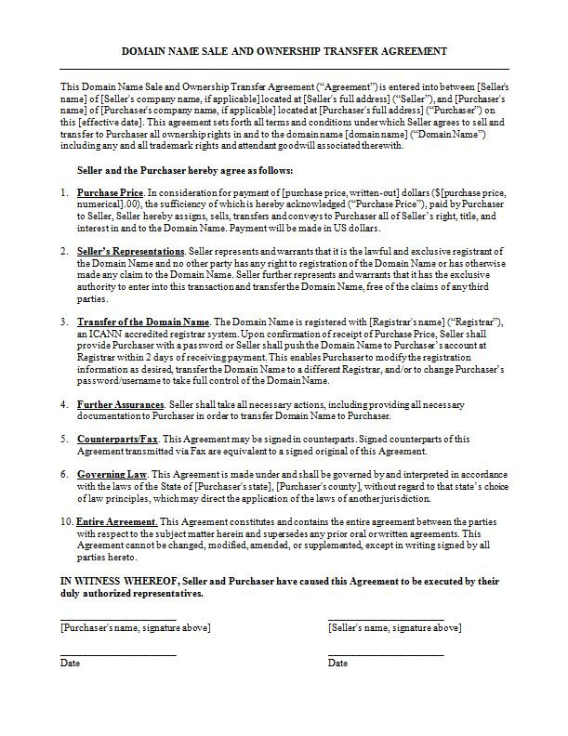
Legal Domain Name Transfer Agreement

Helpful resources
We have provided a lot of helpful resources when it comes to all things concerning domain names. You are more than welcome to make use of some or all of these resources at any time.
You can find all of our helpful online video tutorials at this URL: http://impacthelp.impactsocialmedia.net/

You can find our web page What is a domain name at this URL: http://impactsocialmedia.net/domain-names/what-is-a-domain-name/

You can find our web page about Domain name registration and domain hosting at this URL: http://impactsocialmedia.net/domain-name-registration/domain-hosting/

You can find our web page about Choosing a domain name and how to choose a domain name at this URL: http://impactsocialmedia.net/choosing-a-domain-name/how-to-choose-a-domain-name/

You can find our web page about Setting up a domain and how to setup a domain at this URL: http://impactsocialmedia.net/setting-up-a-domain/how-to-setup-a-domain/

You can find our web page about How to transfer a domain name at this URL:
http://impactsocialmedia.net/domain-transfer/how-to-transfer-a-domain-name/

Impact Social Media

If you are in need of professional assistance for a domain name negotiated purchase, setup, management or transfer we would be happy to earn your business. We offer complete services to research, negotiate and transact any type of negotiated domain purchase. We are also expert at researching, setting up, managing and transferring domain names.
Your domain name is one of the most important elements of your entire digital presence and we want to be sure that you get it right the first time. Contact us today if you would like professional assistance.

If you have questions or need assistance you can email us at:
sales@impactsocialmedia.net

You can also call us at 816-743-0525

Got Impact? Get Impact! How? With Impact Social Media!

